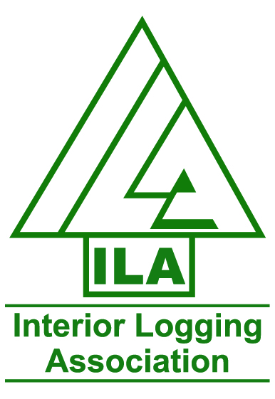

Project Based Training Program
Eligibility Worksheet and Student Application

FOREST HARVESTING
Heavy Equipment Operator Training

Name:

Address:

City: Postal Code:

Phone #:

Cell #:

Email Address:

Do you have a current drivers license? Yes______ No _______

If yes what class of drivers license do you have? _____________________

Are you currently working: Yes No

If yes, Number of hours per week

Wage rate per hour?

Have you completed any university level or Trades Foundation or Apprenticeship levels?

If yes which ones?
Have you received Employment Insurance Benefits in the past 5 years?
Yes No

Have you established a regular Employment Insurance Benefits in the past 3 years
but not received benefits as a result of disqualification? Yes No
Please email, mail or fax in the above application along with a current resume attention:
Wayne Lintott Mail: 3204 – 39th Ave
Email: wayne@interiorlogging.org Vernon, B.C.
Fax: 250 503 2250 V1T 3C8
Questions: Call Wayne at 250.503.2199

